*Chad Nelson and Adrienne Russell*

*Econ 398 | Pope 003*

*The Effect of building temples on surrounding housing prices*

A difference-in-differences analysis

**Introduction:**

The Church of Jesus Christ of Latter-day Saints is a worldwide institution that was founded in the United States in the 1800s. The culminating act of worship for members of the Church takes place in temples – beautiful, ornate buildings that only members[1] may enter. As such, the Church places a high priority on erecting temples throughout the world. These temples can be associated with plausible positive and negative externalities. Among the positive externalities, one could argue that the spotless, well-kept, publicly available grounds and the quiet, almost reverent aura surrounding temples would give external benefit to the surrounding communities. Conversely, the building of a temple could increase traffic and tourist presence in the area and be a perceived encroachment on others’ religious (or lack of) religious beliefs. In our study, we seek to understand the effect of building a temple on surrounding housing prices, specifically in the state of Arizona. We considered Arizona to be the best place to conduct this analysis due to the availability of housing data as well as the relatively large number of temples built in such a small time period. In investigating this causal effect, we hoped to determine if the “temple effect” was a net benefit or cost to surrounding communities.

To this point, there has been minimal work published regarding the effect of Latter-day Saint temples on surrounding housing prices, although there has been much speculation on the topic through anecdotal evidence in the news[2]. The one paper that we found investigating this specific question uses multiple regression as the identification strategy, and purposely avoids looking at temples in areas with high concentrations of members of the Church[3], both of which are different from the methodology this paper employs. In a broader sense, there has been some work done on the effect of places of worship affecting surrounding housing prices, with mixed results (Brandt et al., 2013)[4]. Our work will therefore advance this line of research by adding a unique perspective on the effect of Latter-day Saint temples on housing prices.

**Data:**

Our analysis of the “temple effect” uses data from multiple sources. First, we found a list of temple locations and dedication dates through the Church of Jesus Christ of Latter-day Saints website[5]. From this list, we took the five temples that had been dedicated in Arizona between the years of 2000 and 2020. These five temples (Snowflake, Phoenix, Gilbert, Gila Valley, Tucson) are located in four counties (Navajo, Maricopa, Graham, Pima). We collected data on the temple statistics by hand from various sources[6] (latitudes and longitudes, square footage of each temple, acreage of temple lots, groundbreaking and dedication dates).

Our other main dataset is micro-level data on housing sales in the four counties where the temples of interest were built, which we received from Dr. Pope. This data includes the location of individual homes, their sale prices and dates, and relevant characteristics such as the year the home was built, number of bedrooms/bathrooms, lot size, etc. Although this dataset was mostly complete, there were a few issues with missing data. We manually filled in some of the gaps with missing data by looking up the specific values by home on Zillow[7]. The bathroom count variable required the most attention, followed by the year built and lot size variables. In total, we updated nearly 150 data points. Our efforts to fix as many missing values as possible were crucial in order to have enough observations to conduct a proper analysis. We also dropped all observations that sold for over $2 million to remove the outliers.

We then supplemented these controls with information on county population from US Census records.[8] The micro-level nature of our data lends itself well to our difference-in-differences identification strategy which will be discussed in the next section.

Figure 1 shows summary statistics organized by temple and by home location based on the specified radii. As shown, only three of the original five temples remain. The Snowflake Temple area had no observations before its dedication date (treatment) and the Gila Valley Temple area did not have any observations after treatment. The Gilbert Temple area has by far the most observations while the other two areas seem to be somewhat limited.

**Figure 1**

|  |  |  |  |  |  |  |
| --- | --- | --- | --- | --- | --- | --- |
| **Pre-Treatment**  ***Post-Treatment*** | **Gilbert Temple** | | **Phoenix Temple** | | **Tucson Temple** | |
| **0-0.75 Miles** | **0.75-1.25 Miles** | **0-0.75 Miles** | **0.75-1.25 Miles** | **0-0.75 Miles** | **0.75-1.25 Miles** |
| **Count of Observations** | 84  *16* | 334  *41* | 10  *7* | 83  *13* | 7  *1* | 11  *4* |
| **Avg Selling Price** | $427,993  *$443,367* | $322,617  *$341,332* | $403,794  *$402,871* | $280,687  *$312,465* | $529,674  *$418,000* | $395,666  *$276,250* |
| **Avg Year Built** | 2011  *2014* | 2012  *2012* | 1985  *1988* | 2007  *1991* | 2003  *1968* | 1977  *1978* |
| **Avg Lot Size (Acres)** | .33  *.21* | .22  *.20* | .85  *.84* | .19  *.37* | 1.3  *1.0* | .94  *.51* |
| **Avg Home Size**  **(Sq Ft)** | 3,651  *3,126* | 2,800  *2,703* | 2,953  *3,002* | 2,290  *2,417* | 3,063  *3,128* | 2,704  *1,973* |
| **Avg Plumbing Fixtures** | 12.7  *12.3* | 11.6  *11.2* | 9.5  *10.2* | 9.4  *8.6* | 11.7  *10* | 9.3  *6.8* |

**Identification Strategy:**

Based on the question at hand and the data available to us, we approached this causal question through the use of difference-in-differences (DID). To do so, we identify treatment and control regions surrounding the three remaining temples in Arizona using a process similar to Pope and Pope (Pope & Pope, 2015).[9] Observations are considered treated if they are located within three-quarters of a mile from the newly-built temple, and observations are included in the control group if they are located between three-quarters and one-and-a-quarter miles from the temple. An observed housing transaction is considered pre-treatment if it occurred within a three-year window before the dedication date of the associated temple, and post-treatment if it occurred within a three-year window after the dedication date. For ease of graphical analysis, we split the data into 6 year-long periods centered around each temple’s dedication date. Periods 1-3 are pre-treatment periods while periods 4-6 are post-treatment periods.

Originally, we thought that a half-mile radius would be an appropriate distance for our control group given that the externality of a temple diminishes significantly once the temple is no longer in sight for a given home. However, after examining the data, three-quarters of a mile was as small as we could make our treatment group in order to maintain a reasonable amount of observations in the treatment group. Although this is less than ideal, there is still reason to believe that the externalities of temples can be felt up to three-quarters of a mile, though the effect may be smaller.

The identifying assumption for the DID technique is the parallel trends assumption. In the context of our analysis, we are assuming that housing prices in areas immediately surrounding the temple (within 0.75 miles) followed the same trend as the associated controls (between 0.75 - 1.25 miles) before the temple was built and that they would have continued to do so had the temple not been built. This assumption is far more likely to hold if the houses being sold pre- and post-treatment look similar across treatment and control groups. Figure 1 also serves as such a covariates balance check.

The covariates look the most promising between the control and treatment groups for the Gilbert area. The data for the other two temples is very noisy due to limited numbers of housing transactions in the time periods and geographic areas at hand. For all three temples, the homes in the treatment group appear to be a bit bigger and more expensive on average compared to the homes in the control group. A cause for concern for the Phoenix and Tucson temples is the significant difference in average year built variable and the average lot size variable for homes in treatment and control.

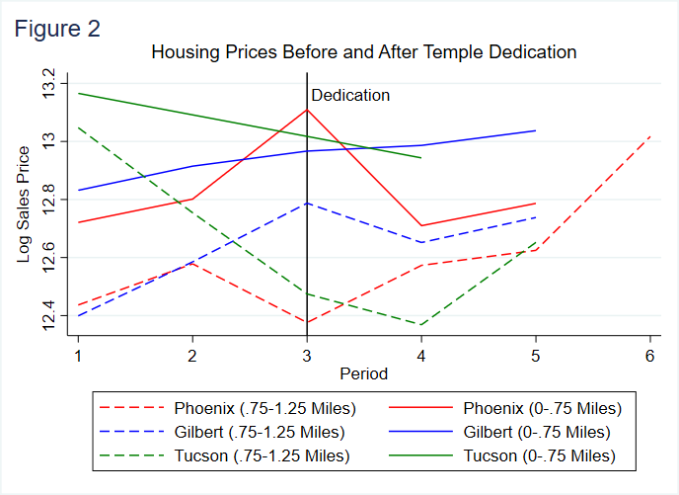Figure 2 displays the trends in housing prices before and after treatment for each area of interest. As expected, Gilbert is to be the only area in which the parallel trends assumption appears plausible to hold. The areas of Tucson and Phoenix simply do not have enough observations in order to see a consistent trend.

Due to these concerns with the parallel trends assumption and the lack of data, our DID analysis focuses exclusively on the Gilbert Arizona area. Figure 3 provides a clearer view of the parallel trends of the Gilbert Area. This undoubtedly reduces the external validity of the causal effect in question but is necessary to produce an accurate analysis.

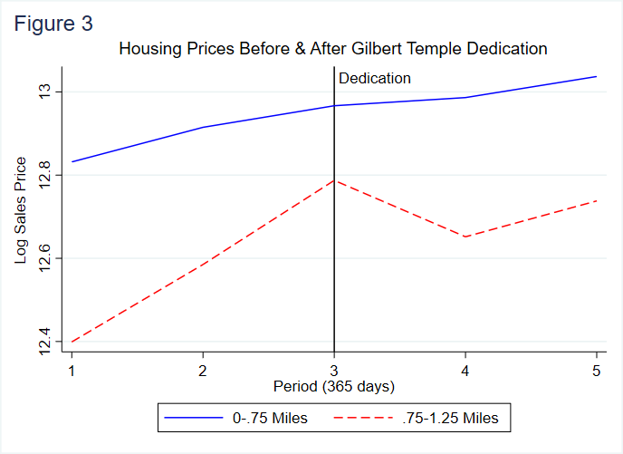

The identifying equation for the spatial difference-in-differences of our analysis is:

${ln(SalesPriceAmount)}_{iym}= βX_{i}+ τ_{y}+ δ{Treat}_{i}+ φ{Treat}_{i}*{Post}_{iym}+ ε_{iym}$ (1)

The dependent variable is the log of the sale price of a house, and our equation includes a vector of house-specific ($i$) covariates that serve as controls ($X_{i}$), year fixed-effects ($τ_{y})$, treatment fixed-effects (${Treat}_{i})$, an interaction between treatment and home ($i$) by year ($y$) by month ($m$) post-treatment indicators (${Treat}_{i}*{Post}_{iym})$, and an error term ($ε_{iym})$. The biggest advantage to using the DID specification is that time-invariant omitted variables will be differenced out, leading to a less biased estimate.

A major issue with using DID to parse out a causal effect is serial correlation. In our case, if a temple is built in 2014, then treatment begins in 2014 but continues over time in each period following dedication. Because of this correlation of treatment over time, it is recommended to adjust standard errors by inflating them to account for the serial correlation present in many DID models. In our case, we adjust standard errors by using robust standard errors in our regression. The popular and useful technique of clustering standard errors would have been appropriate had we pursued our initial analysis including all five temples, however with only Gilbert remaining, we are left to simply use robust standard errors to deal with serial correlation.

**Results:**

The results of our primary regression are displayed in Figure 4. The effect of interest is the coefficient of the interacted term (Treat0.75*Post) in the regression table. As can be seen, the regression estimates a statistically significant, positive 11% increase in local housing prices surrounding the Gilbert temple. This result seems to be due to a large decrease in housing prices in our control group during period 4, while housing prices in our treatment group continued on a slightly positive trajectory throughout the same period. This divergence of trend is clearly seen in Figure 3. The magnitude of the temple effect according to this specification is enormous – far bigger than we anticipated. To conclude that the construction of a temple had a positive effect of 11% on surrounding housing prices in this context would be highly unbelievable. In order to test the robustness of our result and determine if it is in fact causal, we ran two more regressions adjusting the treatment and controls in our model. Discussion of these robustness checks, associated assumptions and results will be discussed in the next section.

**Figure 4**

|  |  |
| --- | --- |
| VARIABLES | lnSalesPriceAmount |
|  |  |
| LotSizeAcres | 0.0336 |
|  | (0.168) |
|  |  |
| YearBuilt | 0.0134* |
|  | (0.00759) |
|  |  |
| PlumbingFixtures | 0.000583 |
|  | (0.00855) |
|  |  |
| BuildingAreaSqFt | 0.000258*** |
|  | (2.90e-05) |
|  |  |
| CountyPopulation | 8.37e-07*** |
|  | (1.60e-07) |
|  |  |
| Treat0.75 | 0.0853** |
|  | (0.0337) |
|  |  |
| Treat0.75*Post | 0.110** |
|  | (0.0537) |
|  |  |
| Constant | -18.39 |
|  | (15.45) |
|  |  |
| Observations | 475 |
| R-squared | 0.690 |

Robust standard errors in parentheses

*** p<0.01, ** p<0.05, * p<0.1

**Robustness Checks**:

As mentioned above, we ran two more regressions varying treatment and control to test the robustness of our causal effect. First, we added a third ring around the two primary rings used in (1). This third ring includes homes located in a radius of 1.25 – 2 miles from the temple. This way, rather than simply having a treatment and control, we have an intense treatment (within 0.75 miles), moderate treatment (0.75 – 1.25 miles) and control (1.25 – 2 miles). This specification allows the estimation of the effect of a temple on prices of homes within our initial radius of 0-0.75 miles as well as homes from 0.75-1.25 miles away, which is instrumental in evaluating the existence of any potential marginal effect a temple may have on surrounding housing prices. Figure 5 shows summary statistics of the Gilbert area by these treatment and control groups, which do look comparable across groups in terms of our control variables. If there is indeed a 10% increase in housing prices for our intense treatment group, we would expect the effect to remain positive and significant when comparing the intense treatment group to the moderate treatment group combined with the further control. Furthermore, we would expect the effect of the temple on housing prices for homes in the moderate treatment group to be positive and significant, although perhaps less extreme.

**Figure 5**

|  |  |  |  |
| --- | --- | --- | --- |
| Pre-Treatment  *Post-Treatment* | Gilbert Temple | | |
| **0-0.75 Miles** | **0.75-1.25 Miles** | **1.25-2 miles** |
| Count of Observations | 84  *16* | 334  *41* | 434  *251* |
| Avg Selling Price | $427,993  *$443,367* | $322,617  *$341,332* | $282,970  *$373,285* |
| Avg Year Built | 2011  *2014* | 2012  *2012* | 2012  *2014* |
| Avg Lot Size (Acres) | .33  *.21* | .22  *.20* | .23  *.20* |
| Avg Home Size (Sq Ft) | 3,651  *3,126* | 2,800  *2,703* | 2,702  *2790* |
| Avg Plumbing Fixtures | 12.7  *12.3* | 11.6  *11.2* | 10.4  *10.8* |

To perform such a regression using DID, we need once again to verify that the parallel trends assumption holds; this time, we must confirm that pre-treatment housing price trends are similar between homes in all three groups (within 0.75 miles, 0.75 – 1.25 miles, 1.25 – 2 miles). Figure 6 shows the trends for each of these groups. It is evident that the trend for the new control (1.25 – 2 miles) does not follow a similar pre-treatment trend to that of either treatment group. There is a significant dip in housing prices for our control in period 2, while neither treatment group experienced similar decline. We checked for any possible outliers that could be skewing the trend in period 2 but found none. While the parallel trends assumption is not strong for this second specification, we still ran the regression to test robustness of our primary regression.

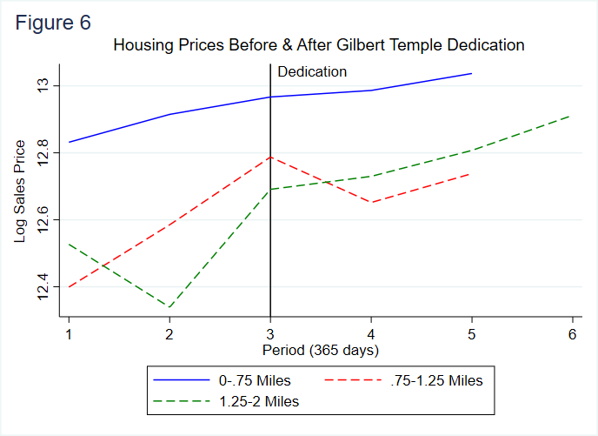

We modeled this second regression using the following equation:

$${\ln\left(SalesPriceAmount\right)}_{iym}= βX_{i}+τ_{y}+δ_{0}{Treat}_{i}^{0.75}+φ_{0}{Treat}_{i}^{1.25}+$$

$(δ_{1}{Treat}_{i}^{0.75}+ φ_{2}{Treat}_{i}^{1.25})*{Post}_{iym}+ ε_{iym}$ (2)

As with equation (1), here we have a vector of the same house-specific controls and a year fixed-effect. We then add fixed effects for both the intense treatment neighborhood and the moderate treatment neighborhood and interacted terms for each of those as well. The results of the regression are shown in Figure 7 under column (2).

The next robustness check was completed by comparing treatment (within 0.75 miles) to a broader control group (0.75 – 2 miles). By combining the two outside rings, we hoped to average out the drop in prices in period 2 seen in the 1.25 – 2 mile radius zone and therefore strengthen the parallel trends assumption for this third regression. The equation for this specification is the same as equation (1), except that our treatment and control indicators are defined differently (as explained above). Results from this regression are shown in Figure 7 under column (3).

**Figure 7**

|  |  |  |  |
| --- | --- | --- | --- |
|  | (1)[10] | (2) | (3) |
| VARIABLES | lnSalesPriceAmount | lnSalesPriceAmount | lnSalesPriceAmount |
|  |  |  |  |
| LotSizeAcres | 0.0336 | 0.317** | 0.292** |
|  | (0.168) | (0.123) | (0.117) |
|  |  |  |  |
| YearBuilt | 0.0134* | 0.0198*** | 0.0187*** |
|  | (0.00759) | (0.00525) | (0.00517) |
|  |  |  |  |
| PlumbingFixtures | 0.000583 | -0.00164 | 0.00310 |
|  | (0.00855) | (0.00442) | (0.00405) |
|  |  |  |  |
| BuildingAreaSqFt | 0.000258*** | 0.000242*** | 0.000235*** |
|  | (2.90e-05) | (2.13e-05) | (2.14e-05) |
|  |  |  |  |
| CountyPopulation | 8.37e-07*** | 4.79e-07** | 5.47e-07** |
|  | (1.60e-07) | (2.17e-07) | (2.14e-07) |
|  |  |  |  |
| Treat0.75 | 0.0853** | 0.179*** | 0.135*** |
|  | (0.0337) | (0.0373) | (0.0351) |
|  |  |  |  |
| Treat0.75*Post | 0.110** | 0.0129 | 0.0496 |
|  | (0.0537) | (0.0453) | (0.0435) |
|  |  |  |  |
| Treat1.25 |  | 0.101*** |  |
|  |  | (0.0186) |  |
|  |  |  |  |
| Treat1.25*Post |  | -0.107** |  |
|  |  | (0.0438) |  |
|  |  |  |  |
| Constant | -18.39 | -30.11*** | -28.03*** |
|  | (15.45) | (10.45) | (10.35) |
|  |  |  |  |
| Observations | 475 | 1,160 | 1,160 |
| R-squared | 0.690 | 0.697 | 0.687 |

Robust standard errors in parentheses

*** p<0.01, ** p<0.05, * p<0.1

The results from these robustness regressions shed some light on the reason behind our large causal effect from the first regression. The most concerning and obvious issue is the fact that our causal effect of interest (the coefficient on the Treat0.75*Post term) goes from a statistically significant positive 11% effect to a statistically insignificant positive 1% effect to a statistically insignificant positive 4% effect, solely as a function of changing the control mechanism. Such variation in our results is likely due to randomness in our data that cannot be averaged out due to the relatively small number of observations we are working with. Regression (2) shed some light on where this issue may be coming from. According to regression (2), the causal effect of being in the moderately treated group (0.75 – 1.25 miles) when the temple was built is a statistically significant, negative 10%. This moderately treated group is the same as our control group from regression (1). Essentially all of the temple effect found in regression (1) can be explained because of a decline in housing prices that occurred only in the 0.75 – 1.25-mile range and not in the inner or outer rings of homes around the temple. This is strong evidence that our parallel trends assumption did not hold for regression (1). Although it looked promising graphically, the assumption that the housing trends would have continued to be similar absent the construction of the temple fails in period 4. Figure 8 shows a residual plot from regression (3). The residual plot from each regression was similar to Figure 8; as shown, the residuals of our control group are noisy and inconclusive. This residual plot supports our concern that we simply did not have a large enough sample size to uncover any sort of statistically significant effect due to a failure of the parallel trends assumption.

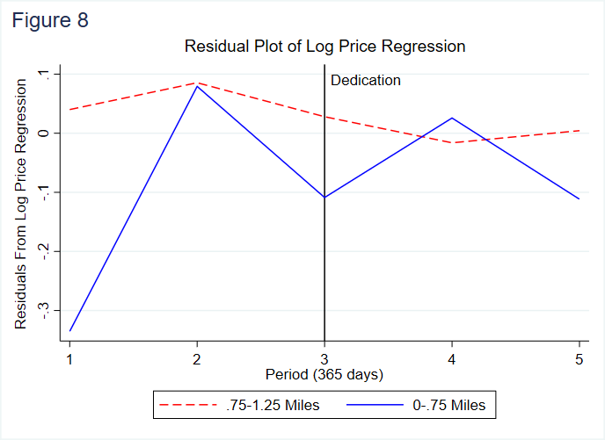

The result from the third regression showing a statistically insignificant yet positive temple effect is more similar to what our expectation of a potential effect was when we first began pursuing this research question.

**Conclusion:**

All three regressions revealed that the construction of the Gilbert Temple had a positive effect on surrounding housing prices within the 0-0.75-mile range, although the magnitude and statistical significance of this effect changed depending on the size of our control group.

In summary, there appears to be no causal impact of building a temple on surrounding housing prices. Although we see some statistically significant results depending on how we define treatment and control groups, those can most likely be attributed to randomness and a small sample size. The dataset only included 16 houses that were sold within our treatment group after the construction of the temple. A sample size this small is very unlikely to produce any sort of reliable estimate, especially given that the expected effect of a temple on housing prices is small to begin with. Further, a sample size this small makes it more unlikely that the parallel trends assumption holds, which is necessary for the DID technique that we employed. Had there been a large increase in housing prices in the treatment group following the temple dedication, there may have been a case for causality. However, the positive effect of the temple on surrounding housing prices appears to mostly be attributed to a random decrease in housing prices within our control group during period 4. This, unfortunately, is not very convincing.

Although we cannot conclude there is any sort of causal effect of the construction of a temple on surrounding houses prices, these results overall align with our initial intuition that the beauty of temples may provide a positive externality to surrounding houses.

The results of this study only apply to the Gilbert Arizona area, so we are not able to conclude much about the effect of a temple on housing prices in any given area. Our analysis would have carried a little more external validity if we were not forced to drop the other Arizona temples due to the lack of valid data. If we were to further pursue this question in the future, we would ideally look for data around a wide range of temples in multiple states. This would increase our sample size resulting in more reliable causal estimates and simultaneously add some external validity to any discovered causal effect.

**Sources:**

1. the only occasion where nonmembers can enter a temple is the Temple Open House that occurs in the couple of months before the dedication (or rededication in the case of extensive renovation) of the temple.
2. Merkley, L. (2019, Oct 8). New temples bring excitement, traffic, and higher housing prices. *The Daily Universe,* Retrieved from <https://universe.byu.edu/2019/10/08/new-temples-bring-excitement-and-higher-housing-prices/>

   Associated Press. (2007, Dec 22). As LDS temples rise, home values do, too. *Deseret News,* Faith, Retrieved from <https://www.deseret.com/2007/12/22/20060504/as-lds-temples-rise-home-values-do-too>

   Roe, G. (2019, Apr 8). Will new temple increase home values in Tooele County? Experts say maybe. *2KUTV,* News, Retrieved from <https://kutv.com/news/local/will-new-temple-increase-home-values-in-tooele-county-experts-say-maybe>
3. Danderson, S. J. (2003) The impact of LDS temples on local property values. Retrieved from <https://www.fairlatterdaysaints.org/wp-content/uploads/2011/12/danderson-the-impact-of-lds-temples.pdf>
4. Brandt, S., Maennig, W., and Richter, F. (2013) Do places of worship affect housing prices? Evidence from Germany, *Hamburg Contemporary Economic Discussions*, No. 48, ISBN 978-3-942820-11-0, University of Hamburg, Faculty of Business, Economics and Social Sciences, Chair for Economic Policy, Hamburg. Retrieved from <https://www.econstar.eu/bitstream/10419/92962/1/769643752.pdf>
5. *Temple List.* Retrieved from <https://www.churchofjesuschrist.org/temples/list?lang=eng>
6. *Temple Dimensions.* Retrieved from

   <https://churchofjesuschristtemples.org/statistics/dimensions/>

   *Google Earth.* Retrieved from <https://earth.google.com/web>
7. *Zillow.* Retrieved from <https://zillow.com>
8. County Population Totals: 2010 – 2019. *United States Census Bureau.* Retrieved from <https://www.census.gov/data/datasets/time-series/demo/popest/2010s-counties-total.html>
9. Pope, D. G., Pope, J. C. (2015). When Walmart comes to town: Always low housing prices? Always?. *Journal of Urban Economics,* 87, 1-13. Retrieved from <https://www.sciencedirect.com/science/article/pii/S0094119014000795>
10. Column (1) contains the results from our original regression using only the treatment (within 0.75 miles) and the single control (0.75 – 1.25 miles).